**VISVESVARAYA TECHNOLOGICAL UNIVERSITY, BELAGAVI 590018**



Report on

**“Cloud Task Scheduling Based on Min-Min Algorithm”**

By

Shreeprada Divakar Bhat (1BM15CS100) Sowkhya S Adiga (1BM15CS110)

Vatsala Jha (1BM15CS123)

Under the Guidance of

**(Rajeshwari B S)**

Assistant Professor, Department of CSE

BMS College of Engineering

Work carried out at



Department of Computer Science and Engineering

BMS College of Engineering

(Autonomous college under VTU)

P.O. Box No.: 1908, Bull Temple Road, Bangalore-560 019

2016-2017

**BMS College of EngineerinG**

**DEPARTMENT OF COMPUTER SCIENCE AND ENGINEERING**



***CERTIFICATE***

This is to certify that the Cloud Computing assignment titled **“ Cloud Task Scheduling Based on Min-Min Algorithm ”** has been carried out by Shreeprada Divakar Bhat (1BM15CS100),Sowkhya S Adiga (1BM15CS110), Vatsala Jha(1BM15CS123), during the academic year 2017-2018.

Signature of the guide

**Rajeshwari B S**

Assistant Professor,

Department of Computer Science and Engineering

BMS College of Engineering, Bangalore

**BMS College of EngineerinG**

**DEPARTMENT OF COMPUTER SCIENCE AND ENGINEERING**



***DECLARATION***

Shreeprada Divakar Bhat (1BM15CS100), Sowkhya S Adiga (1BM15CS110), Vatsala Jha(1BM15CS123), students of 6th Semester, B.E, Department of Computer Science and Engineering, BMS College of Engineering, Bangalore, hereby declare that, this assignment work entitled " **Cloud Task Scheduling Based on Min-Min Algorithm**" has been carried out by us under the guidance of **Rajeshwari B S,** Assistant Professor, Department of CSE, BMS College of Engineering, Bangalore during the academic semester Jan-May 2018. We also declare that to the best of our knowledge and belief, the assignment reported here is not from part of any other report by any other students.

**Signature of the Candidates**

Shreeprada Divakar Bhat (1BM15CS100)

Sowkhya S Adiga (1BM15CS110)

Vatsala Jha (1BM15CS123)

**Index**

# Introduction

## Main Features

# Architecture

# 2.1 Modeling the Cloud

## 2.2 Modeling VM allocation

# Example programs

# Algorithm and Flowchart

# Code

# Results

# Conclusion

# References

1. Introduction

Recently, cloud computing emerged as the leading technology for delivering reliable, secure, fault-tolerant, sustainable, and scalable computational services, which are presented as Software, Infrastructure, or Platform as services (SaaS, IaaS, PaaS). Moreover, these services may be offered in private data centers (private clouds), may be commercially offered for clients (public clouds), or yet it is possible that both public and private clouds are combined in hybrid clouds.



Figure 1

## Above diagram shows the layered design of Cloud computing architecture. Physical Cloud resources along with core middleware capabilities form the basis for delivering IaaS and PaaS. The user-level middleware aims at providing SaaS capabilities. The top layer focuses on application services (SaaS) by making use of services provided by the lower-layer services. PaaS/SaaS services are often developed and provided by third-party service providers, who are different from the IaaS providers.

## Cloud applications: This layer includes applications that are directly available to end-users. We define end-users as the active entity that utilizes the SaaS applications over the Internet. These applications may be supplied by the Cloud provider (SaaS providers) and accessed by end-users either via a subscription model or on a pay-per-use basis. Alternatively, in this layer, users deploy their own applications. In the former case, there are applications such as Salesforce.com that supply business process models on clouds (namely, customer relationship management software) and social networks. In the latter, there are e-Science and e-Research applications, and Content-Delivery Networks.

## User-Level middleware: This layer includes the software frameworks, such as Web 2.0 Interfaces (Ajax, IBM Workplace), that help developers in creating rich, cost-effective user-interfaces for browser-based applications. The layer also provides those programming environments and composition tools that ease the creation, deployment, and execution of applications in clouds. Finally, in this layer several frameworks that support multi-layer applications development, such as Spring and Hibernate, can be deployed to support applications running in the upper level

## Core middleware: This layer implements the platform-level services that provide run-time environment for hosting and managing User-Level application services. The core services at this layer include Dynamic SLA Management, Accounting, Billing, Execution monitoring and management, and Pricing (are all the services to be capitalized?). The well-known examples of services operating at this layer are Amazon EC2, Google App Engine, and Aneka. The functionalities exposed by this layer are accessed by both SaaS (the services represented at the top-most layer in above diagram) and IaaS (services shown at the bottom-most layer in above diagram) services. Critical functionalities that need to be realized at this layer include messaging, service discovery, and load-balancing. These functionalities are usually implemented by Cloud providers and offered to application developers at an additional premium. For instance, Amazon offers a load-balancer and a monitoring service (Cloudwatch) for the Amazon EC2 developers/consumers. Similarly, developers building applications on Microsoft Azure clouds can use the .NET Service Bus for implementing message passing mechanism.

## System Level: The computing power in Cloud environments is supplied by a collection of data centers that are typically installed with hundreds to thousands of hosts. At the System-Level layer, there exist massive physical resources (storage servers and application servers) that power the data centers. These servers are transparently managed by the higher-level virtualization services and toolkits that allow sharing of their capacity among virtual instances of servers. These VMs are isolated from each other, thereby making fault tolerant behavior and isolated security context possible.

These already wide ecosystem of cloud architectures, along with the increasing demand for energy-efficient IT technologies, demand timely, repeatable, and controllable methodologies for evaluation of algorithms, applications, and policies before actual development of cloud products. Because utilization of real testbeds limits the experiments to the scale of the testbed and makes the reproduction of results an extremely difficult undertaking, alternative approaches for testing and experimentation leverage development of new Cloud technologies.

A suitable alternative is the utilization of simulations tools, which open the possibility of evaluating the hypothesis prior to software development in an environment where one can reproduce tests. Specifically in the case of Cloud computing, where access to the infrastructure incurs payments in real currency, simulation-based approaches offer significant benefits, as it allows Cloud customers to test their services in repeatable and controllable environment free of cost, and to tune the performance bottlenecks before deploying on real Clouds. At the provider side, simulation environments allow evaluation of different kinds of resource leasing scenarios under varying load and pricing distributions. Such studies could aid the providers in optimizing the resource access cost with focus on improving profits. In the absence of such simulation platforms, Cloud customers and providers have to rely either on theoretical and imprecise evaluations, or on try-and-error approaches that lead to inefficient service performance and revenue generation.

The primary objective of this project is to provide a generalized, and extensible simulation framework that enables seamless modeling, simulation, and experimentation of emerging Cloud computing infrastructures and application services. By using CloudSim, researchers and industry-based developers can focus on specific system design issues that they want to investigate, without getting concerned about the low level details related to Cloud-based infrastructures and services.

## 1.1 Main features

Overview of CloudSim functionalities:

* support for modeling and simulation of large scale Cloud computing data centers
* support for modeling and simulation of virtualized server hosts, with customizable policies for provisioning host resources to virtual machines
* support for modeling and simulation of application containers
* support for modeling and simulation of energy-aware computational resources
* support for modeling and simulation of data center network topologies and message-passing applications
* support for modeling and simulation of federated clouds
* support for dynamic insertion of simulation elements, stop and resume of simulation
* support for user-defined policies for allocation of hosts to virtual machines and policies for allocation of host resources to virtual machines

1. **Architecture**

Figure 2 shows the multi-layered design of the CloudSim software framework and its

Architectural components. Initial releases of CloudSim used SimJava as the discrete event simulation engine that supports several core functionalities, such as queuing and processing of events, creation of Cloud system entities (services, host, data center, broker, VMs), communication between components and management of the simulation clock.

The CloudSim simulation layer provides support for modelling and simulation of virtualized

Cloud-based data center environments including dedicated management interfaces for VMs,

memory, storage, and bandwidth. The fundamental issues, such as provisioning of hosts to VMs,

managing application execution, and monitoring dynamic system state, is handled by this layer.

A Cloud provider, who wants to study the efficiency of different policies in allocating its hosts to

VMs (VM provisioning), would need to implement his strategies at this layer. Such implementation can be done by programmatically extending the core VM provisioning functionality. There is a clear distinction at this layer related to provisioning of hosts to VMs.

A Cloud host can be concurrently allocated to a set of VMs that execute applications based on SaaS provider’s defined QoS levels. This layer also exposes the functionalities that a Cloud application developer can extend to perform complex workload profiling and application performance study. The top-most layer in the CloudSim stack is the User Code that exposes basic entities for hosts (number of machines, their specification, and so on), applications (number of tasks and their requirements), VMs, number of users and their application types, and broker scheduling policies. By extending the basic entities given at this layer, a Cloud application developer can perform the following activities:

* 1. generate a mix of workload request distributions, application configurations;
  2. model Cloud availability scenarios and perform robust tests based on the custom configurations; and
  3. implement custom application provisioning techniques for clouds and their

federation.



Figure 2

* 1. **Modelling the cloud**

The infrastructure-level services (IaaS) related to the clouds can be simulated by extending the

Data center entity of CloudSim. The data center entity manages a number of host entities. The

hosts are assigned to one or more VMs based on a VM allocation policy that should be defined by the Cloud service provider. Here, the VM policy stands for the operations control policies related to VM life cycle such as: provisioning of a host to a VM, VM creation, VM destruction, and VM migration. Similarly, one or more application services can be provisioned within a single VM instance, referred to as application provisioning in the context of Cloud computing. In the context of CloudSim, an entity is an instance of a component. A CloudSim component can be a class (abstract or complete) or set of classes that represent one CloudSim model (data center, host).

A data center can manage several hosts that in turn manage VMs during their life cycles. Host

is a CloudSim component that represents a physical computing server in a Cloud: it is assigned

a pre-configured processing capability (expressed in millions of instructions per second—MIPS),

memory, storage, and a provisioning policy for allocating processing cores to VMs. The Host

component implements interfaces that support modelling and simulation of both single-core and

multi-core nodes.

VM allocation (provisioning) is the process of creating VM instances on hosts that match the

critical characteristics (storage, memory), configurations (software environment), and requirements (availability zone) of the SaaS provider.

CloudSim supports the development of custom application service models that can be deployed within a VM instance and its users are required to extend the core Cloudlet object for implementing their application services. Furthermore, CloudSim does not enforce any limitation on the service models or provisioning techniques that developers want to implement and perform tests with. Once an application service is defined and modelled, it is assigned to one or more pre-instantiated VMs through a service-specific allocation policy.

Allocation of application-specific VMs to hosts in a Cloud-based data center is the responsibility

of a VM Allocation controller component (called VmAllocationPolicy). This component exposes

a number of custom methods for researchers and developers who aid in the implementation of

new policies based on optimization goals (user centric, system centric, or both). By default,

VmAllocationPolicy implements a straightforward policy that allocates VMs to the Host on a

First-Come-First-Serve (FCFS) basis. Hardware requirements, such as the number of processing

cores, memory, and storage, form the basis for such provisioning. Other policies, including the

ones likely to be expressed by Cloud providers, can also be easily simulated and modelled in

CloudSim.

For each Host component, the allocation of processing cores to VMs is done based on a host

allocation policy. This policy takes into account several hardware characteristics, such as number

of CPU cores, CPU share, and amount of memory (physical and secondary), that are allocated to

a given VM instance. Hence, CloudSim supports simulation scenarios that assign specific CPU

cores to specific VMs (a space-shared policy), dynamically distribute the capacity of a core among VMs (time-shared policy), or assign cores to VMs on demand.

Each host component also instantiates a VM scheduler component, which can either implement

the space-shared or the time-shared policy for allocating cores to VMs. Cloud system*/*application

developers and researchers can further extend the VM scheduler component for experimenting

with custom allocation policies. In the next section, the finer-level details related to the timeshared and space-shared policies are described.

Fundamental software and hardware configuration parameters related to VMs are defined in the VM class. Currently, it supports modelling of several VM configurations offered by Cloud providers such as the Amazon EC2.

* 1. **Modelling the VM allocation**

One of the key aspects that make a Cloud computing infrastructure different from a Grid computing infrastructure is the massive deployment of virtualization tools and technologies. Hence, as against Grids, Clouds contain an extra layer (the virtualization layer) that acts as an execution, management, and hosting environment for application services. Hence, traditional application provisioning models that assign individual application elements to computing nodes do not accurately represent the computational abstraction, which is commonly associated with Cloud resources.

For example, consider a Cloud host that has a single processing core. There is a requirement of concurrently instantiating two VMs on that host. Although in practice VMs are contextually (physical and secondary memory space) isolated, still they need to share the processing cores and system bus. Hence, the amount of hardware resources available to each VM is constrained by the total processing power and system bandwidth available within the host. This critical factor must be considered during the VM provisioning process, to avoid creation of a VM that demands more processing power than is available within the host. In order to allow simulation of different provisioning policies under varying levels of performance isolation, CloudSim supports VM provisioning at two levels: first, at the host level and second, at the VM level. At the host level, it is possible to specify how much of the overall processing power of each core will be assigned to each VM.

At the VM level, the VM assigns a fixed amount of the available processing power to the individual application services (task units) that are hosted within its execution engine. We consider a task unit as a finer abstraction of an application service being hosted in the VM.

At each level, CloudSim implements the time-shared and space-shared provisioning policies. To

clearly illustrate the difference between these policies and their effect on the application service

performance, in Figure 4 we show a simple VM provisioning scenario. In this figure, a host with

two CPU cores receives request for hosting two VMs, such that each one requires two cores and

plans to host four tasks’ units. More specifically, tasks t1, *t*2, t3, and t4 to be hosted in VM1,

whereas t5, t6, t7, and t8 to be hosted in VM2.

Figure 3(a) presents a provisioning scenario, where the space-shared policy is applied to both

VMs and task units. As each VM requires two cores, in space-shared mode only one VM can run

at a given instance of time. Therefore, VM2 can only be assigned the core once VM1 finishes the

execution of task units. The same happens for provisioning tasks within the VM1: since each task unit demands only one core, therefore both of them can run simultaneously. During this period, the remaining tasks (2 and 3) wait in the execution queue. By using a space-shared policy, the estimated finish time of a task *p* managed by a VM *i* is given by

**

Where *est*(*p*) is the Cloudlet- (cloud task) estimated start time and *rl* is the total number of

instructions that the Cloudlet will need to execute on a processor. The estimated start time depends on the position of the Cloudlet in the execution queue, because the processing unit is used exclusively (space-shared mode) by the Cloudlet. Cloudlets are put in the queue when there are free processing cores available that can be assigned to the VM. In this policy, the total capacity of a host having *np* processing elements (PEs) is given by:

*,*

Where *cap*(*i*) is the processing strength of individual elements.

In Figure 3(b), a space-shared policy is applied for allocating VMs to hosts and a time-shared

policy forms the basis for allocating task units to processing core within a VM. Hence, during a

VM lifetime, all the tasks assigned to it are dynamically context switched during their life cycle. By using a time-shared policy, the estimated finish time of a Cloudlet managed by a VM is given by

**

Where *eft(p)* is the estimated finish time, *ct* is the current simulation time, and *cores(p)* is the

number of cores (PEs) required by the Cloudlet. In time-shared mode, multiple Cloudlets (task

units) can simultaneously multi-task within a VM. In this case, we compute the total processing

capacity of Cloud host as

**

where *cap*(*i*) is the processing strength of individual elements.

In Figure 3(c), a time-shared provisioning is used for VMs, whereas task units are provisioned

based on a space-shared policy. In this case, each VM receives a time slice on each processing

core, which then distributes the slices among task units on a space-shared basis. As the cores

are shared, the amount of processing power available to a VM is variable. This is determined by

calculating VMs that are active on a host. As the task units are assigned based on a space-shared

policy, which means that at any given instance of time only one task will be actively using the

processing core.

Finally, in Figure 3(d) a time-shared allocation is applied to both VMs and task units. Hence, the

processing power is concurrently shared by the VMs and the shares of each VM are simultaneously divided among its task units. In this case, there are no queuing delays associated with task units.



Figure 3

Effects of different provisioning policies on task unit execution: (a) space-shared

provisioning for VMs and tasks; (b) space-shared provisioning for VMs and time-shared provisioning for tasks; (c) time-shared provisioning for VMs, space-shared provisioning for tasks (d) time-shared provisioning for VMs and tasks.

1. **Example Programs**
2. Example 1

How to create a data center with one host and run cloudlet on it.

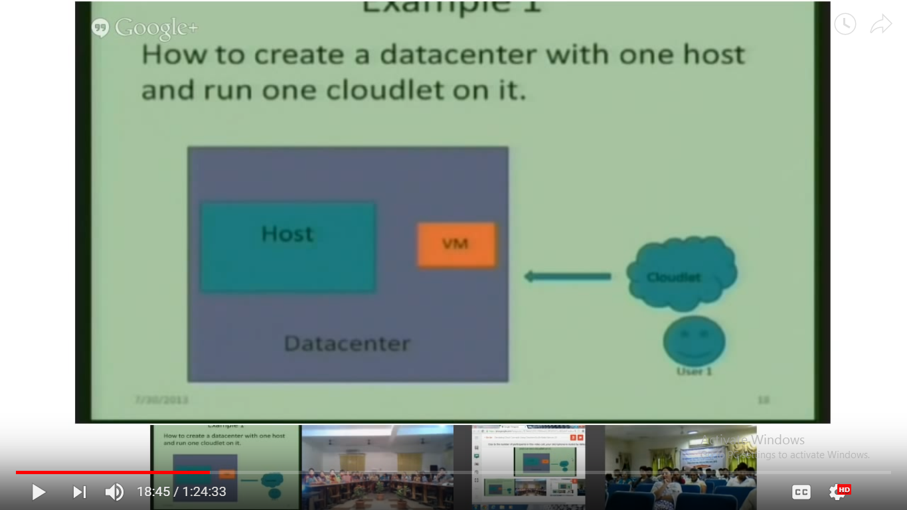

1. Example 2

How to create a datacenter with one host and runs two cloudlets on it. The cloudlets run in Vm’s with the same MIP’s requirements.

The cloudlets will take the same time to compute the execution.

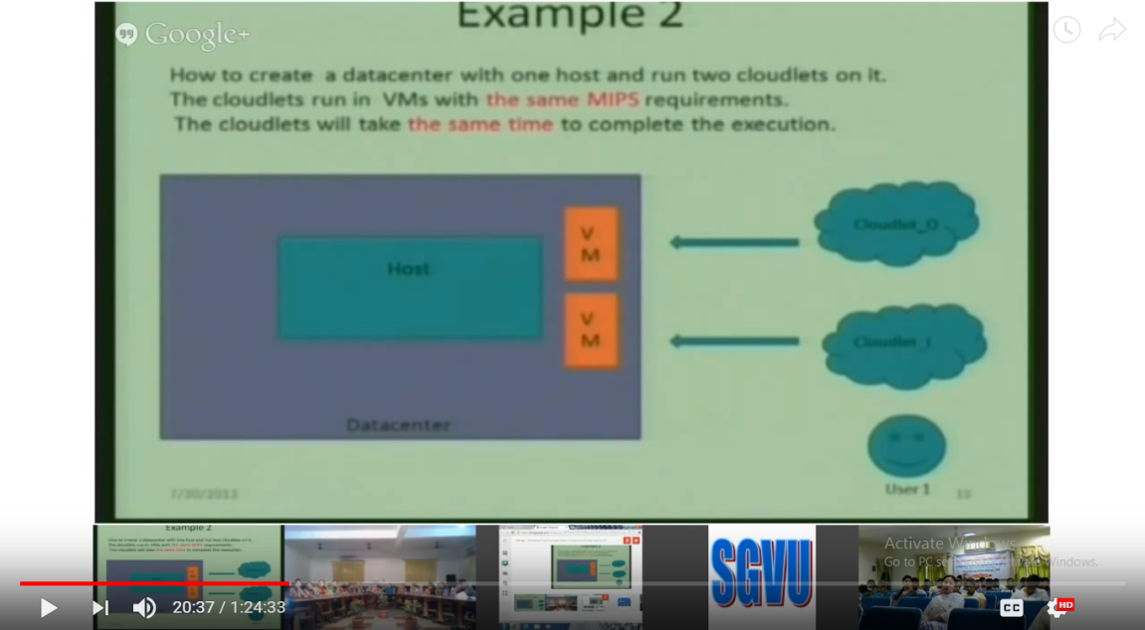

1. Example 3

How to create a datacenter with two hosts and run two cloudlets on it.

The cloudlets run in Vm’s with d/f MIP’s reqirements.

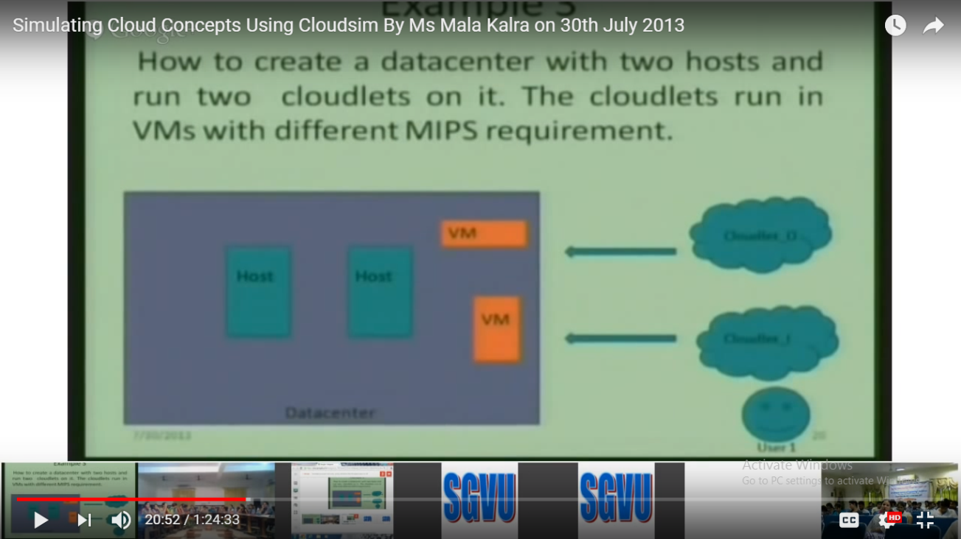

1. Example 4

How to create two data centers with one host each and run two cloudlets on them.

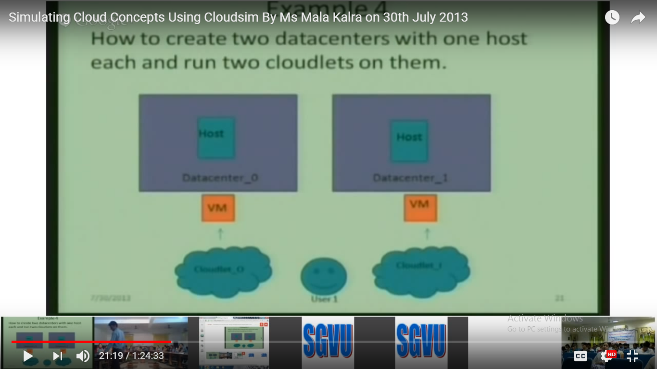

5.Example 5

Showing how to create two data centers with one host each and run cloudlets of two users on them.

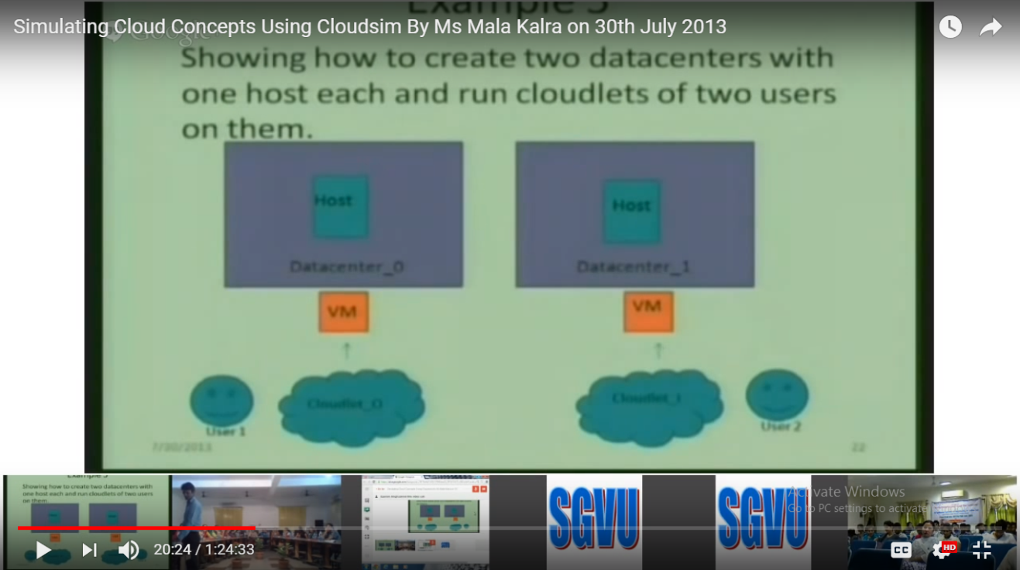

1. **.** Example 6

Showing how to create scalable simulations

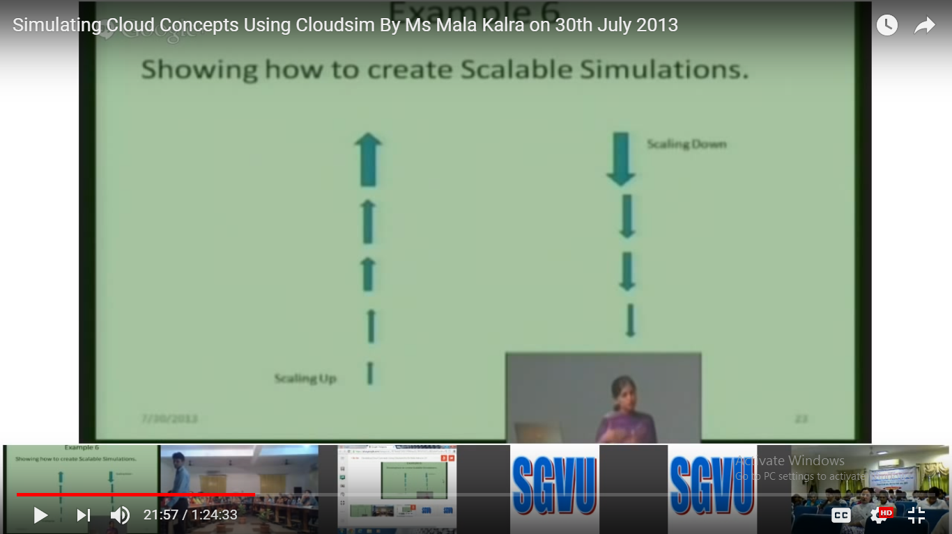

1. **Algorithm of the scheduling process with flowchart**

* Min-Min scheduling algorithm is one of the heuristic task scheduling algorithm.
* Min-Min algorithm starts with set of all unmapped tasks. The machines which have the minimum completion time for a job are selected. Then the job with overall minimum completion time is selected and mapped to that resource. The ready time of the resource is updated.
* This process is repeated until all the unmapped tasks are assigned.
* It produces better makespan.
* The complexity of Min-Min algorithm when we have R resources and T tasks is O(T^2*R).
* **Algorithm**

**1. for all tasks ti in meta-task Mv (in an arbitrary order)**

**2. for all machines mj (in a fixed arbitrary order)**

**3. cij  = eij +rj**

**4. do until all tasks in Mv are mapped**

**5. for each task in Mv  find the earliest completion time and the machine that obtains it.**

**6. Find the task tk  with the minimum earliest completion time**

**7. Assign task tk to the machine ml that gives the earliest completion time.**

**8. Delete task tk from Mv**

**9. Update rl**

**10. Update cil  for all i.**

**11. End of do**

**FlowChart**

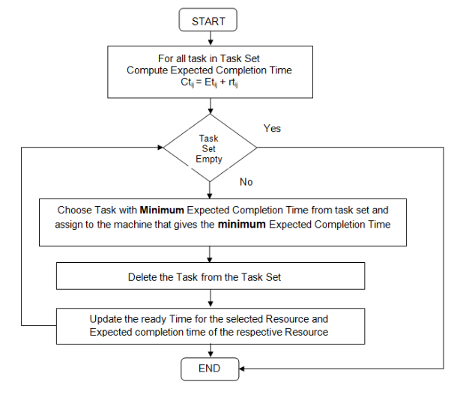

**5.CODE for Min-Min Scheduling**

package org.cloudbus.cloudsim.examples;

import java.text.DecimalFormat;

import java.util.ArrayList;

import java.util.Calendar;

import java.util.LinkedList;

import java.util.List;

import java.util.Random;

import org.cloudbus.cloudsim.Cloudlet;

import org.cloudbus.cloudsim.CloudletSchedulerSpaceShared;

import org.cloudbus.cloudsim.Datacenter;

import org.cloudbus.cloudsim.DatacenterBrokerMin;

import org.cloudbus.cloudsim.DatacenterCharacteristics;

import org.cloudbus.cloudsim.Host;

import org.cloudbus.cloudsim.Log;

import org.cloudbus.cloudsim.Pe;

import org.cloudbus.cloudsim.Storage;

import org.cloudbus.cloudsim.UtilizationModel;

import org.cloudbus.cloudsim.UtilizationModelFull;

import org.cloudbus.cloudsim.Vm;

import org.cloudbus.cloudsim.VmAllocationPolicySimple;

import org.cloudbus.cloudsim.VmSchedulerTimeShared;

import org.cloudbus.cloudsim.core.CloudSim;

import org.cloudbus.cloudsim.provisioners.BwProvisionerSimple;

import org.cloudbus.cloudsim.provisioners.PeProvisionerSimple;

import org.cloudbus.cloudsim.provisioners.RamProvisionerSimple;

public class MinMinSchedule {

/** The cloudlet list. */

private static List<Cloudlet> cloudletList;

/** The vmlist. */

private static List<Vm> vmlist;

private static List<Vm> createVM(int userId, int vms, int idShift) {

//Creates a container to store VMs. This list is passed to the broker later

LinkedList<Vm> list = new LinkedList<Vm>();

//VM Parameters

long size = 10000; //image size (MB)

int ram = 1024; //vm memory (MB)

int mips = 500;

long bw = 1000;

int pesNumber = 1; //number of cpus

String vmm = "Xen"; //VMM name

//create VMs

Vm[] vm = new Vm[vms];

for(int i=0;i<vms;i++){

vm[i] = new Vm(idShift + i, userId, mips, pesNumber, ram, bw, size, vmm, new CloudletSchedulerSpaceShared());

list.add(vm[i]);

}

return list;

}

private static List<Cloudlet> createCloudlet(int userId, int cloudlets, int idShift){

// Creates a container to store Cloudlets

LinkedList<Cloudlet> list = new LinkedList<Cloudlet>();

//cloudlet parameters

long length = 1000;

long fileSize = 300;

long outputSize = 300;

int pesNumber = 1;

UtilizationModel utilizationModel = new UtilizationModelFull();

Cloudlet[] cloudlet = new Cloudlet[cloudlets];

for(int i=0,j=0;i<cloudlets;i++,j=j+50){

Random rojb=new Random();

cloudlet[i] = new Cloudlet(idShift + i, length+rojb.nextInt(2000), pesNumber, fileSize, outputSize, utilizationModel, utilizationModel, utilizationModel);

// setting the owner of these Cloudlets

cloudlet[i].setUserId(userId);

list.add(cloudlet[i]);

}

return list;

}

/**

* Creates main() to run this example

*/

public static void main(String[] args) {

Log.printLine("Starting .......");

try {

// First step: Initialize the CloudSim package. It should be called

// before creating any entities.

int num_user = 1; // number of cloud users

Calendar calendar = Calendar.getInstance();

boolean trace_flag = false; // mean trace events

// Initialize the CloudSim library

CloudSim.init(num_user, calendar, trace_flag);

// Second step: Create Datacenter

@SuppressWarnings("unused")

Datacente datacenter0 = createDatacenter("Datacenter_0");

//Third step: Create Broker

DatacenterBrokerMin broker = createBroker();

int brokerId = broker.getId();

vmlist = createVM(brokerId, 3, 0); //creating 3 vms

cloudletList = createCloudlet(brokerId, 10, 0); // creating 10 cloudlets

//submit vm list to the broker

broker.submitVmList(vmlist);

//submit cloudlet list to the broker

broker.submitCloudletList(cloudletList);

//bind the cloudlets to the vms. This way, the broker

// will submit the bound cloudlets only to the specific VM

broker.bindCloudletToVmsMinMin();

// Sixth step: Starts the simulation

CloudSim.startSimulation()

// Final step: Print results when simulation is over

List<Cloudlet> newList = broker.getCloudletReceivedList();

CloudSim.stopSimulation();

printCloudletList(newList);

DatacenterBrokerMin.calculateAvgTurnAroundTime(cloudletList);

DatacenterBrokerMin.calculateThroughput(cloudletList);

Log.printLine(MinMinSchedule.class.getName()+" finished!");

}

catch (Exception e) {

e.printStackTrace();

Log.printLine("The simulation has been terminated due to an unexpected error");

}

}

private static Datacenter createDatacenter(String name){

// Here are the steps needed to create a PowerDatacener

List<Host> hostList = new ArrayList<Host>();

// 2. A Machine contains one or more PEs or CPUs/Cores

List<Pe> peList = new ArrayList<Pe>();

int mips = 2000;

// 3. Create PEs and add these into a list.

peList.add(new Pe(0, new PeProvisionerSimple(mips)));

peList.add(new Pe(1, new PeProvisionerSimple(mips)));

//4. Create Host with its id and list of PEs and add them to the list of machines

int hostId=0;

int ram = 16384; //host memory (MB)

long storage = 1000000; //host storage

int bw = 10000;

hostList.add(

new Host(

hostId,

new RamProvisionerSimple(ram),

new BwProvisionerSimple(bw),

storage,

peList,

new VmSchedulerTimeShared(peList)

)

); // This is our machine

// 5. Create a DatacenterCharacteristics object that stores the

// properties of a data center: architecture, OS, list of

// Machines, allocation policy: time- or space-shared, time zone

// and its price (G$/Pe time unit).

String arch = "x86"; // system architecture

String os = "Linux"; // operating system

String vmm = "Xen";

double time_zone = 10.0; // time zone this resource located

double cost = 3.0; // the cost of using processing in this resource

double costPerMem = 0.05; // the cost of using memory in this resource

double costPerStorage = 0.001; // the cost of using storage in this resource

double costPerBw = 0.0; // the cost of using bw in this resource

LinkedList<Storage> storageList = new LinkedList<Storage>();

DatacenterCharacteristics characteristics = new DatacenterCharacteristics(

arch, os, vmm, hostList, time_zone, cost, costPerMem, costPerStorage, costPerBw);

// 6. Finally, we need to create a PowerDatacenter object.

Datacenter datacenter = null;

try {

datacenter=newDatacenter(name,characteristics,newVmAllocationPolicySimple(hostList), storageList, 0);

} catch (Exception e) {

e.printStackTrace();

}

return datacenter;

}

private static DatacenterBrokerMin createBroker(){

DatacenterBrokerMin broker = null;

try {

broker = new DatacenterBrokerMin("Broker");

} catch (Exception e) {

e.printStackTrace();

return null;

}

return broker;

}

/**

* Prints the Cloudlet object

*/

private static void printCloudletList(List<Cloudlet> list) {

int size = list.size();

Cloudlet cloudlet;

String indent = " ";

Log.printLine();

Log.printLine("========== OUTPUT ==========");

Log.printLine("Cloudlet ID" + indent + "STATUS" + indent +

"Data center ID" + indent + "VM ID" + indent + "Time" + indent + "Start Time" + indent + "Finish Time");

DecimalFormat dft = new DecimalFormat("###.##");

for (int i = 0; i < size; i++) {

cloudlet = list.get(i);

Log.print(indent + cloudlet.getCloudletId() + indent + indent);

if (cloudlet.getCloudletStatus() == Cloudlet.SUCCESS){

Log.print("SUCCESS");

Log.printLine( indent + indent + cloudlet.getResourceId() + indent + indent + indent + cloudlet.getVmId() +

indent + indent + dft.format(cloudlet.getActualCPUTime()) + indent + indent + dft.format(cloudlet.getExecStartTime())+

indent + indent + dft.format(cloudlet.getFinishTime()));

}

}

}

public void bindCloudletToVmsMinMin(){

int vmNum=vmList.size();

//ready time for each machine initially to be 0

Double[] readyTime=new Double[vmNum];

for(int i=0;i<readyTime.length;i++){

readyTime[i]=0.0;

}

//initialize 2D matrix with ready time+completion time

List<List<Double>> tasksVmsMatrix = *create2DMatrix*(cloudletList,vmList);

int count=1;

do{

System.*out*.println("===============================================");

System.*out*.println("This is start of iteration" + count);

*print2DArrayList*(tasksVmsMatrix);

Map<Integer[],Double> map=*findMinMinTimeMap*(tasksVmsMatrix);

*printMapForMinMin*(map);

Integer[] rowAndColIndexAndCloudletId=*getRowAndColIndexesAndCloudletId*(map);

Double min=*getMinimumTimeValue*(map);

int rowIndex=rowAndColIndexAndCloudletId[0];

int columnIndex=rowAndColIndexAndCloudletId[1];

int cloudletId=rowAndColIndexAndCloudletId[2];

cloudletList.get(cloudletId).setVmId(vmList.get(columnIndex).getId());

System.*out*.println("The cloudlet " +cloudletId + "has been assigned to VM " + columnIndex);

Double oldReadyTime=readyTime[columnIndex]; //store the old value

readyTime[columnIndex]=min;

System.*out*.println("The ready time array is:" + Arrays.*toString*(readyTime));

*updateTotalTimeMatrix*(columnIndex,oldReadyTime,readyTime,tasksVmsMatrix);

tasksVmsMatrix.remove(rowIndex);

System.*out*.println("This is end of iteration "+count);

System.*out*.println("===========================================");

count++;

}while(tasksVmsMatrix.size()>0);

}

private static void updateTotalTimeMatrix(int columnIndex, Double oldReadyTime, Double[] readyTime,

List<List<Double>> tasksVmsMatrix) {

Double newReadyTime=readyTime[columnIndex];

Double readyTimeDifference=newReadyTime-oldReadyTime;

for(int row=0;row<tasksVmsMatrix.size();row++){

Double oldTotalTime=tasksVmsMatrix.get(row).get(columnIndex);

Double newTotalTime=oldTotalTime+readyTimeDifference;

tasksVmsMatrix.get(row).set(columnIndex, newTotalTime);

}

}

private static Double getMinimumTimeValue(Map<Integer[], Double> map) {

Double value=0.0;

for(Entry<Integer[],Double> entry:map.entrySet()){

value=entry.getValue();

}

return value;

}

private static Integer[] getRowAndColIndexesAndCloudletId(Map<Integer[], Double> map) {

Integer[] key=new Integer[3];

for(Entry<Integer[],Double> entry:map.entrySet()){

key=entry.getKey();

}

return key;

}

private static void printMapForMinMin(Map<Integer[], Double> map) {

for(Entry<Integer[],Double> entry:map.entrySet()){

Integer[] key=entry.getKey();

Double value= entry.getValue();

System.*out*.println("The keys are : "+"{" +key[0]+","+key[1]+","+key[2]+"}");

System.*out*.println("The min is:"+value+", located art row "+key[0]+" column "+key[1]+" and the cloudlet id is :"+key[2]);

}

}

private static Map<Integer[], Double> findMinMinTimeMap(List<List<Double>> tasksVmsMatrix) {

List<Integer[]> indexList=new ArrayList<Integer[]>();

int colNum=tasksVmsMatrix.get(0).size(); //column number

Integer initialCloudletId=tasksVmsMatrix.get(0).get(colNum-1).intValue();

Integer[] indexOfMin={0,0,initialCloudletId};

Double min=tasksVmsMatrix.get(0).get(0);

indexList.add(indexOfMin);

int rowNum=tasksVmsMatrix.size();

for(int row=0;row<rowNum;row++){

int colNumWithoutLastColumn=tasksVmsMatrix.get(row).size()-1;

for(int col=0;col<colNumWithoutLastColumn;col++){

Double current=tasksVmsMatrix.get(row).get(col);

if(current<min){

//retrieve the index only

min=current;

Integer targetCloudletId = (tasksVmsMatrix.get(row).get(colNumWithoutLastColumn)).intValue();

Integer[] indexOfCurrent = {row,col,targetCloudletId};

indexList.add(indexOfCurrent);

}

}

}

Map<Integer[],Double> map =new HashMap<Integer[],Double>();

Integer[] rowAndColIndexAndCloudletId = new Integer[3];

rowAndColIndexAndCloudletId[0]=indexList.get(indexList.size()-1)[0];

rowAndColIndexAndCloudletId[1]=indexList.get(indexList.size()-1)[1];

rowAndColIndexAndCloudletId[2]=indexList.get(indexList.size()-1)[2];

map.put(rowAndColIndexAndCloudletId, min);

return map;

}

private static void print2DArrayList(List<List<Double>> table){

System.*out*.printf("The current matrix is as below,with size of %d by %d \n",table.size(),table.get(0).size());

for(int i=0;i<table.size();i++){

for(int j=0;j<table.get(i).size();j++){

System.*out*.printf("%-11.5f",table.get(i).get(j));

}

System.*out*.printf("\n");

}

}

private static List<List<Double>> create2DMatrix(List<? extends Cloudlet> cloudletList,List<? extends Vm>vmList){

List<List<Double>> table=new ArrayList<List<Double>>();

for(int i=0;i<cloudletList.size();i++){

Double originalCloudletId=(double)cloudletList.get(i).getCloudletId();

List<Double> temp=new ArrayList<Double>();

for(int j=0;j<vmList.size();j++){

Double load=cloudletList.get(i).getCloudletLength()/vmList.get(j).getMips();

temp.add(load);

}

// last index position points to the original id

temp.add(originalCloudletId);

table.add(temp);

}

return table;

}

public static double calculateAvgTurnAroundTime(List<? extends Cloudlet> cloudletList){

double totalTime=0.0;

int cloudletNum=cloudletList.size();

for(int i=0;i<cloudletNum;i++){

totalTime+=cloudletList.get(i).getFinishTime();

}

double avgTurnAroundTime=totalTime/cloudletNum;

System.*out*.printf("The average TurnAround Time is %.4f \n",avgTurnAroundTime);

return avgTurnAroundTime;

}

public static double calculateThroughput(List<? extends Cloudlet> cloudletList){

double maxFinishTime=0.0;

int cloudletNum=cloudletList.size();

for(int i=0;i<cloudletNum;i++){

double currentFinishTime=cloudletList.get(i).getFinishTime();

if(currentFinishTime>maxFinishTime){

maxFinishTime=currentFinishTime;

}

}

double throughput=cloudletNum/maxFinishTime;

System.*out*.printf("The throughput is %.6f \n",throughput);

return throughput;

}

}

**6.Experimental Data and Results**

**Input Data**

|  |  |
| --- | --- |
| **Number of Vms** | **3** |
| **Numbet of Cloudlets** | **10** |
| **Numbet of Datacenters** | **1** |
| **Number of Hosts** | **1** |
| **Ram required for VM** | **1024(MB)** |
| **MI of Cloudlets** | **Random** |
| **MIPS of VMs** | **500** |
| **VM allocation** | **Time shared** |
| **Cloudlet allocation** | **Space shared** |

**Output**

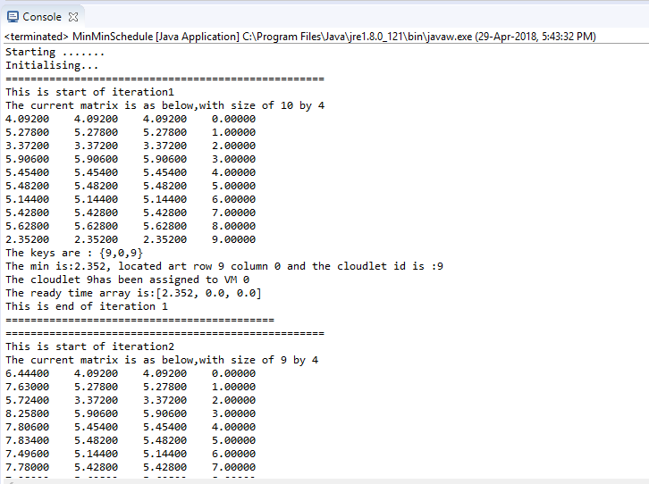

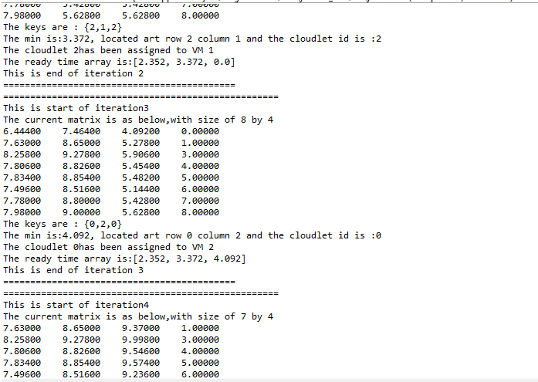

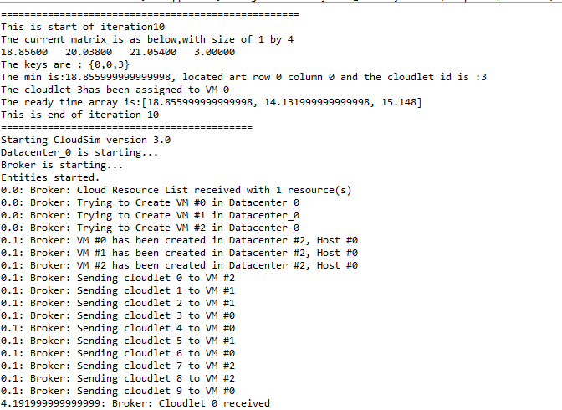

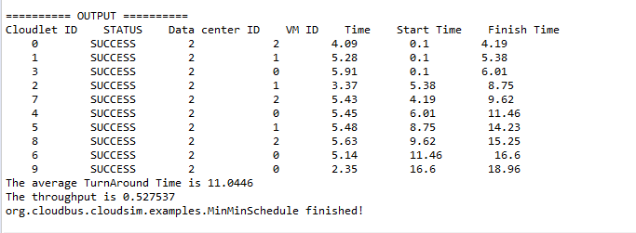

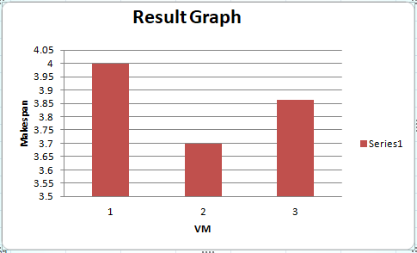

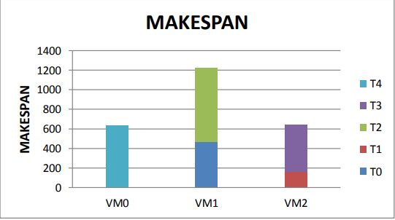

**7.Conclusion**

The simulation result shows that the Min-Min scheduling minimizes the makespan and guarantees the high system availability in system performance. This scheduling shows that it has better quality of system load balancing and the utilization of system resources. With the help of better resource allocation for tasks and minimization of makespan for the workflow the performance and throughput is increased in the system hence the reliability of system is also increased.

**8.References**

**[1]** CloudSim: a toolkit for modeling and simulation of cloud computing environments and evaluation of resource provisioning algorithms “,Rodrigo N. Calheiros, Rajiv Ranjan, Anton Beloglazov1, C´esar A. F. De Rose and Rajkumar Buyya, SOFTWARE – PRACTICE AND EXPERIENCE *Softw. Pract. Exper.* 2011; **41**:23–50, DOI: 10.1002/spe.995, 24 August 2010

[2] Cloud computing Principle and Paradigm:text book by Rajkumar Buyya , John wicky and sons Inc.

[3] cloud computing a practical approach : Text bok by Anthony T velte,Robert Elsenpeter.

[4] Cloud Analyst : a simulation model toolkit

[5] www.researchgate.net